Home Page

Top Navigation-
Shop All , Face Care, Body Care, Hero Ingredients , About Us

Shop All – Needs to reflect all SKU’s
Face Care – Needs to have these options – Serums, Face Cleanser, Moisturisers
Body Care – Body Cleanser, Body Lotion, Body Cream, Body Scrubs, Bath Salts
Hero Ingredients ( I will Share in a separate Sheet)
About Us –( Hero Statement
Skincare with Purpose
Cilla Skyn™ is a modern African skincare brand creating thoughtful, sensorial formulations inspired by nature and refined by science.
We believe skincare should do more than simply sit on the skin. It should feel considered, purposeful and beautifully balanced — from the ingredients chosen to the textures experienced and the rituals created around them.
Thoughtfully formulated. Purposefully layered. Inspired by nature.

Our Story
A Name Rooted in Love & Legacy
Cilla Skyn™ was created from a deeply personal place, one rooted in love, care and intention.
The name Cilla comes from Priscilla, my mother and the inspiration at the heart of the brand. Her strength, warmth and presence inspired a name that carries something deeply personal, while reflecting the values we want every Cilla Skyn™ product to embody.
What began as a personal inspiration evolved into a vision for skincare that feels both meaningful and modern. A vision centred on thoughtfully selected ingredients, elevated textures and a genuine respect for the skin.
Cilla Skyn™ represents a modern expression of African skincare, celebrating the richness of our botanical heritage while embracing the possibilities of contemporary cosmetic science.
Every formula is created with intention, bringing together nature, science and sensorial experience to transform everyday skincare into a ritual that feels considered, comforting and beautifully your own.
CILLA SKYN™ is pronounced SILL-UH SKIN.
A name inspired by love and legacy.
A modern African skincare story.

Our Formulation Approach
Every Ingredient Should Have a Purpose

At Cilla Skyn™, every formula begins with the skin barrier.

We believe a healthy, well-supported barrier creates the foundation for skin to feel balanced, resilient and better able to tolerate and benefit from targeted active ingredients.

From there, we formulate with purpose — combining barrier-supportive ingredients, hydrators, botanicals and carefully selected actives according to the role they play within the complete formula.

We focus on balance, compatibility and meaningful concentrations, rather than simply creating the longest ingredient list.

Because effective skincare is not about more.

It is about giving the skin what it needs, in a formulation designed to work together.

Support the barrier.
Target with intention.
Formulate with purpose.

Home page ( Landing Page layout)

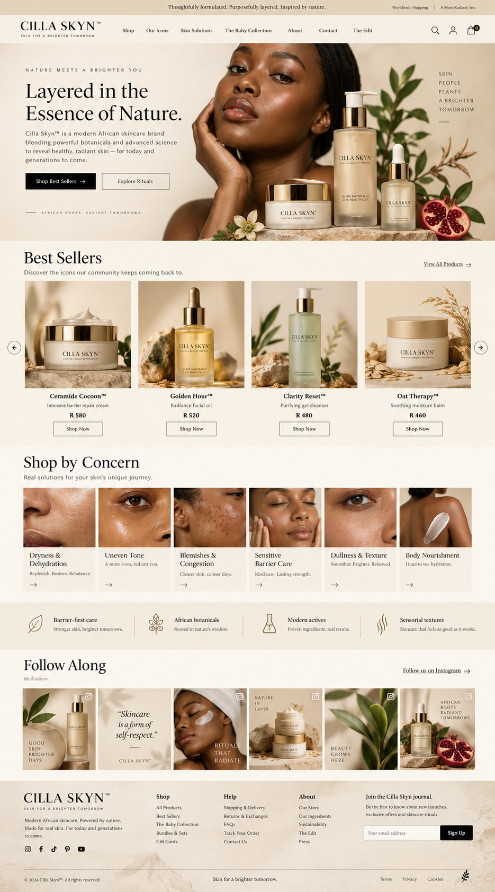



Cilla Skyn product list by category

Face Cleansers
Clarity Reset™ Clarifying Gel Face Wash
Quench Cleanse™ Hydrating Jelly Face Wash
Facial Serums & Treatments
Golden Hour™ Brightening Serum-Emulsion
H-P-E Triad™ Advanced Night Renewal Serum
Clarity Reset™ Clarifying Serum
Cera-Ectoin Clarity Reset™ Barrier Balance Mist
Face Moisturisers & Creams
Petal Plush™ Silky Hydration Day Cream
Glow in the Dark™ Overnight Recovery Cream
Quench™ Water-Burst Hydration Gel-Cream
Clarity Reset™ Face Lotion
Facial Oils
Bakuchi Renewal Renewal Facial Oil
Pure Rosehip Oil
Pure Argan Oil
Face + Body Treatments / Masks
Clarity Reset™ Clarifying Face + Body Mask
(working product — previously explored as Clear Intentions / Pore Decisions / Muddy)
Body Lotions & Creams
Ceramide Cocoon™ Barrier Repair Body Lotion
Kalahari Nectar™ Even Tone Hydrating Body Lotion
Silhouette Therapy™ Firming Body Lotion
Body Oils
Oat Therapy Soothing Lipid Body Oil
Kalahari Nectar Vitamin C Body Oil
Glow & Tell Radiance Body Oil Gel
Body Cleansers
Earth and Ember Shower Gel
Smooth Operator Shower Gel
Urea Comfort Shower Gel
Body Scrubs & Polishes
Mango Soufflé™ Energising Massage Body Polish
Rhassoul Clay Body Polish
Nila Dunes Body Scrub
Honey Roast Body Scrub
Bath Soaks & Bath Treatments
Oat Therapy / Avena Sativa Therapy Bath Soak
Serenity Bath Soak
Awaken Citrus Sunrise Bath Soak
Mineral Recovery Magnesium Bath Blend

Contact Information:
Whatsapp: +27 64 911 1932
Instagram: @Cillaskyn
Email: Info@cillaskyn.co.za

Shop by concerns

Oily & Acne Prone
Product | Primary Role
Clarity Reset Clarifying Gel Face Wash | Oil, congestion, blemishes
Clarity Reset Clarifying Serum | Blemishes, pores, uneven texture
Clarity Reset Face Lotion | Lightweight hydration + blemish support
Clarity Reset Barrier Balance Mist | Hydration, oil balance + barrier support
Clarity Reset Clarifying Face + Body Mask | Congestion, oiliness + pore care
ABS Salicylic Body Wash | Body breakouts, congestion + rough texture

Senstive and Eczema Prone
Product | Primary Role
Ceramide Cocoon Barrier Repair Body Lotion | Barrier repair + intensive hydration
Oat Therapy Soothing Lipid Body Oil | Lipid replenishment + moisture sealing
Oat Therapy / Avena Sativa Therapy Milky Bath Soak | Soothing bath treatment
Clarity Reset Barrier Balance Mist | Lightweight barrier support
Quench Water Burst Hydration Gel Cream | Hydration + barrier support
Quench Cleanse Hydrating Jelly Face Wash | Gentle cleansing
Pure Argan Oil | Nourishment + barrier conditioning

Dry and Dull
Product | Primary Role
Quench Cleanse Hydrating Jelly Face Wash | Gentle hydrating cleanse
Quench Water Burst Hydration Gel Cream | Lightweight water-based hydration
Petal Plush Silky Hydration Day Cream | Daily moisturising + radiance
Glow in the Dark Overnight Recovery Cream | Overnight replenishment
Pure Argan Oil | Nourishing facial oil
Pure Rosehip Oil | Nourishment + softness
Bakuchi Renewal Facial Oil | Renewal + nourishment
Ceramide Cocoon Body Lotion | Deep body hydration
Oat Therapy Body Oil | Replenishing body oil
Kalahari Nectar Body Lotion | Hydration + even-tone care
Glow & Tell Radiance Body Oil Gel | Softness + glow

Uneven Tone, Dark Marks & Radiance
Product | Primary Role
Golden Hour Brightening Serum Emulsion | Uneven tone + visible dark marks
Petal Plush Silky Hydration Day Cream | Brightness + hydration
Kalahari Nectar Even Tone Body Lotion | Uneven body tone + dark marks
Kalahari Nectar Vitamin C Body Oil | Radiance + nourishing body care
Pure Rosehip Oil | Dullness + uneven-looking skin
Bakuchi Renewal Facial Oil | Tone, texture + radiance
Squalane Halo Radiance Body Oil Gel | Instant glow + nourishment
Mango Soufflé Body Polish | Removes dull surface buildup
Rhassoul Clay Body Polish | Smoother, clearer-looking skin

Texture, Renewal & Ageing Skin
Product | Primary Role
H P E Triad Advanced Night Renewal Serum | Advanced overnight renewal
Bakuchi Renewal Facial Oil | Gentle renewal + texture
Glow in the Dark Overnight Recovery Cream | Recovery + plumping hydration
Pure Rosehip Oil | Mature, dry + uneven-looking skin
Golden Hour Brightening Serum Emulsion | Tone + smoother-looking skin
Petal Plush Day Cream | Hydration + antioxidant support

Firmness, Elasticity & Stretch Mark Care
Product | Primary Role
Silhouette Therapy Firming Body Lotion | Firmness, elasticity + stretch-mark appearance
Kalahari Nectar Vitamin C Body Oil | Nourishment + antioxidant support
Kalahari Nectar Even Tone Body Lotion | Tone + body hydration
Oat Therapy Body Oil | Elasticity-supporting lipid nourishment
Glow & Tell Body Oil Gel | Conditioning + suppleness

Body Wellness & Bath Rituals
Product | Positioning
Oat Therapy / Avena Sativa Therapy Milky Bath Soak | Soothe + comfort
Serenity Bath Soak | Relax + unwind
Awaken Citrus Sunrise Bath Soak | Refresh + energise
Mineral Recovery Magnesium Bath Blend | Recover + restore

Recommended website “Shop by Concern”
For the actual homepage/navigation,
Oily & Acne Prone
Sensitive & Eczema Prone
Dry & Dehydrated
Uneven Tone & Dark Marks
Texture & Ageing
Firmness & Body Texture

